**Assignment 5: Network Operations**

**1.Write a script that checks if a list of remote servers is reachable over SSH**

#!/bin/bash

FILE="$1"

if [ ! -f "$FILE" ]; then

echo "Server list not found!"

exit 1

fi

while read -r server; do

echo "Checking SSH on $server..."

if ssh -o BatchMode=yes -o ConnectTimeout=5 "$server" exit 2>/dev/null; then

echo "$server is reachable via SSH"

else

echo "$server is NOT reachable via SSH"

fi

done < "$FILE"

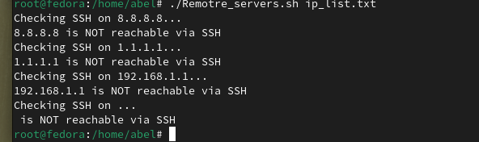

**2. Ping IPs and Report Average Response Time**

#!/bin/bash

FILE="$1"

if [ ! -f "$FILE" ]; then

echo "IP list not found!"

exit 1

fi

while read -r ip; do

echo "Pinging $ip..."

avg=$(ping -c 4 "$ip" | grep 'rtt' | awk -F'/' '{print $5}')

if [ -n "$avg" ]; then

echo "$ip average response time: ${avg} ms"

else

echo "$ip is unreachable"

fi

done < "$FILE"

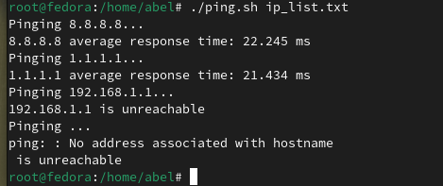

**3. Website Status with HTTP Request**

#!/bin/bash

URL="$1"

if [ -z "$URL" ]; then

echo "Usage: $0 <website_url>"

exit 1

fi

status=$(curl -s -o /dev/null -w "%{http_code}" "$URL")

if [ "$status" -eq 200 ]; then

echo "$URL is UP"

else

echo "$URL is DOWN (Status Code: $status)"

fi

